Software Requirements Specification

Stock Market

Version 1.0

Prepared by

Table of Contents

1. Introduction

1.1 Purpose

1.2 Document Conventions

1.3 Intended Audience and Reading Suggestions

1.4 Project Scope

1.5 References

2. Overall Description

2.1 Product Perspective

2.2 Product Features

**1. Introduction**

**1.1 Purpose**

The scope of the stock market system website includes creating a user-centric online platform tailored to facilitate stock trading and investment activities. Users will have the capability to register, log in, and manage their profiles. The website will enable users to place buy and sell orders for stocks, track their order status, and view their portfolio holdings. Additionally, administrators will have the authority to manage user accounts, oversee stock data, and ensure the integrity of the system. The website's scope is designed to encompass an engaging and efficient trading experience for users while maintaining robust control mechanisms for administrators.

**1.2 Scope**

The scope of the stock market system website includes creating a user-centric online platform tailored to facilitate stock trading and investment activities. Users will have the capability to register, log in, and manage their profiles. The website will enable users to place buy and sell orders for stocks, track their order status, and view their portfolio holdings. Additionally, administrators will have the authority to manage user accounts, oversee stock data, and ensure the integrity of the system. The website's scope is designed to encompass an engaging and efficient trading experience for users while maintaining robust control mechanisms for administrators.

**2. Functional Requirements**

2.1 User Registration

- The system shall allow users to register by providing their personal information.

- The system shall validate user information and ensure unique usernames.

2.2 User Authentication

- The system shall provide a login mechanism for registered users.

- The system shall authenticate users based on their login credentials.

2.3 Stock Listings

- The system shall provide a list of available stocks with their current prices.

- The system shall display detailed information about each stock, including historical data and company information.

2.4 Buying/Selling Stocks

- The system shall allow users to place buy or sell orders for stocks.

- The system shall validate the availability of stocks and user account balances before executing orders.

- The system shall update user account balances and stock quantities based on successful transactions.

2.5 Portfolio Management

- The system shall maintain a portfolio for each user, displaying their current holdings and their market value.

- The system shall provide a summary of the user's portfolio performance, including profit/loss calculations.

2.6 Transaction History

- The system shall maintain a transaction history for each user, recording all buy/sell orders and their outcomes.

- The system shall allow users to view their transaction history, including details such as date, time, stock, quantity, and price.

**3. Non-Functional Requirements**

3.1 Performance

- The system should be able to handle a large number of concurrent users and process transactions efficiently.

3.2 Security

3.2.1 User passwords should be securely stored using encryption techniques.

3.2.2 Access to sensitive user data should be protected through appropriate authentication mechanisms.

3.3 Scalability

- The system should be designed to accommodate future growth and increasing data volume.

3.4 Reliability

3.4.1 The system should have a high availability to ensure users can access and trade stocks without frequent downtimes.

3.5 User-Friendly Interface

- The user interface should be intuitive and easy to navigate, allowing users to interact with the system seamlessly.

**4.System Design**

**4.1 Use case Diagram**

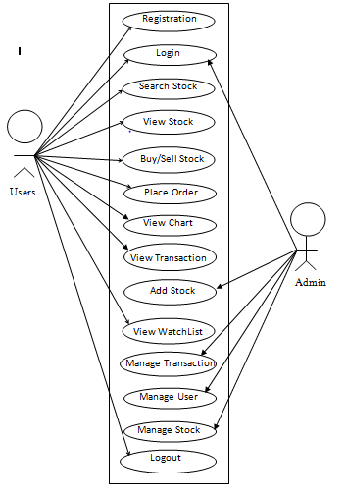

4.2 Activity Diagram

